EXTENDED ABSTRACT TITLE
(TITLE: TIMES NEW ROMAN, SIZE 14, BOLD, CAPITAL, CENTRE)

First Author¹, Second Author² and Third Author³

^{1, 2} Authors’ Department, Institute, City, COUNTRY.
(E-mail: firstauthorsname@aaaa.bbb, secondauthorsname@aaaa.bbb)
³ Author’s Department, Institute, City, COUNTRY.
(E-mail: thirdauthorsname@aaaa.bbb)

ABSTRACT
(HEADING 2: TIMES NEW ROMAN, SIZE 12, BOLD, CAPITAL, CENTRE)
The abstract should be typed in single-spaced, Justify, in 10-points Times New Roman and not be more than 300 words. The abstract should not only indicate the subject and scope of the paper but also summarize the author’s conclusion. Structured abstract must be a brief, comprehensive summary of the contents of the article. It allows readers to survey the contents of an article quickly. An abstract summarizes the major aspects of a paper. It should concisely summarize the purpose of the paper, the methods used, the major results, and conclusions.
Keywords: Keyword 1, Keyword 2, Keyword 3 (Min 3 Keywords & Max 5 Keywords)

1.0 INTRODUCTION
In this section, the author should address the following information which is the background, problems and objectives of the research.

This is a template document which contains the format of extended abstract for IGNITE 2026. All submissions should strictly follow this format to ensure a consistent, high-quality appearance proceeding. The author can download the template from the conference website. The easiest way to format your paper exactly like this template document is simply to replace the content with your own material.

Author should follow the following guidelines. The extended abstract should be written in MS Word format in single-spaced in 12-point Times New Roman except for abstract. Do not indent the text paragraphs. Each paragraph must be single-spacing separated (Click icon ‘¶’ at the Home Tools).

Authors are requested to submit the extended abstracts in electronic form (MS-Word). Please ensure the extended abstract has a minimum of 4 pages and maximum of 5 pages in the length excluding the references. The pages should not be numbered. The incorrect formats may result in your abstract being returned to you by e-mail.

2.0 METHODOLOGY
In this section, author should explain the design phase, development phases, and evaluation techniques. Author can describe the product/innovation idea product/innovation idea in terms of its features, functionality, usefulness and practicality.

2.1 First, Second and Third Level of Heading
First degree titles (2.0) should be written left aligned, all caps and bold. Second- and third-degree subtitles (2.1., 2.1.1.) should be written left aligned, bold and with title case. A blank line should be placed between the paragraphs and there should not be any paragraph indentation.

3.0 RESULTS AND DISCUSSION
In this section, author should address the following information which is finding and discussion. Please observe Figure 1 and Table 1 to include figure and table in the extended abstract, respectively. A figure should be inserted like the one below and referred to in the text.

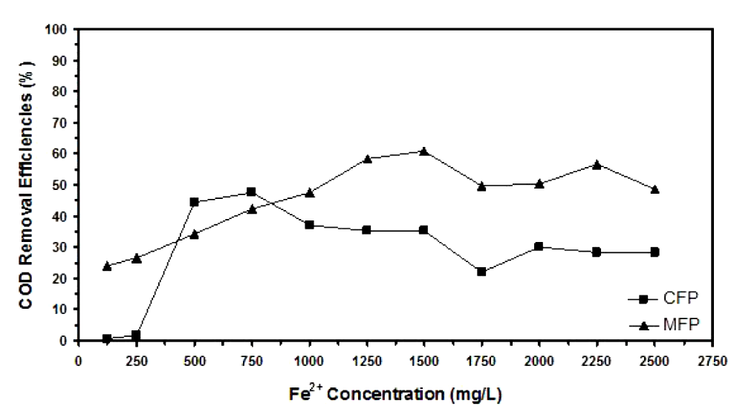
Figure 1. Example of figure for the extended abstract.

A table should be inserted like the one below and referred to in the text. Please avoid vertical rules and shading in table cells.

Table 1. Example of table for the extended abstract
Contents of Table | Label

4.0 CONCLUSION
The conclusion should summarize your work incorporating your most important findings, future recommendations as well as and commercial potential.

ACKNOWLEDGMENT
The authors can include an acknowledgment to express their appreciation for the support of the sponsors. Include details such as research grant, individual(s), or name(s) of organization/institution.

REFERENCES (No Numbering, APA Style)
References should be listed in alphabetical order and presented in a format according to the APA Style.

Examples:

(Journal Article)
Ruxton, C. (2016). Tea: Hydration and other health benefits. Primary Health Care, 26(8), 34-42. https://doi.org/10.7748/phc.2016.e1162

Wahyuni, E. T., Diantariani, N. P., Kartini, I., & Kuncaka, A. (2022). Enhancement of the photostability and visible photoactivity of ZnO photocatalyst used for reduction of Cr(VI) ions. Results in Engineering, 13, 100351. https://doi.org/10.1016/j.rineng.2022.100351

(Book)
Jani, A. M. M., Yazid, H., Habiballah, A. S., Mahmud, A. H., & Losic, D. (2015). Nanoporous Alumina: Fabrication, Structure, Properties and Applications (Vol. 219): Springer.

